Evidence that cabbage palms are invading Blocks A and B of NATL’s upland pine ecosystem
Tom Walker, 27 Oct 2014
- When restoration on these two blocks started, no one noticed that Sabal palmetto grew there, and some would have thought it noteworthy if they had seen one.
- Dan Ward’s1999-2003 inventory of vascular plants of NATL, did not record them in upland pine. Instead he reported, “Sabal palmetto, Cabbage Palm; Infrequent; hammock, wetlands (E9, F7, K12).”
Two of the three NATL gridblocks that Ward indicated are hammock and the other includes part of the Sinkhole Pond.
- In 1997, in the first grid-based photographic record of NATL, 39 photos had fields of view that were entirely or partly in UP Block A or B. In only two of these was a cabbage palm detected and both of these had a maximum foliage height of no more than 1m. In fact, one of these had escaped detection until a taller version was detected in the 2007 photographic record. Both that were in 1997 photos were along the DPI fence and outside the area that has been regularly subject to controlled burns since 1996 (i.e., they were west of the DPI Trail).
In 19 of the 39 photos, the field of view was entirely within UP Block A or B; in 18 it was 50% within, and in 2 it was <50%.
- In 2007, a second grid-based photographic record of NATL was made. Inspection of the 39 photos that corresponded to the 39 photos described above in “3.” revealed five with cabbage palms: the two that had a palm before, and three others.
- The two palms first photographed in 1997 were photographed again in 2014. Fig. 1 and 2 show the 1999, 2007, and 2014 photographs of each palm. These are also online (larger and in color) at http://natl.ifas.ufl.edu/photogallery/D5n.htm and http://natl.ifas.ufl.edu/photogallery/D7n.htm.
The palms along the fence likely owe their presence to birds that had recently eaten palm fruit perching on the fence and releasing the seeds with their droppings. Compared to those growing on the frequently burned east side of the DPI trail, the seedlings along the fence might have grown faster ,because of something DPI did on their side of the fence, or slower, because of being shaded by the dense growth along the fence.
- On 22 April 2014, following a 9 April burn of the two blocks, cabbage palm individuals were easy to detect. Those detected were assigned to one of three development stages and their positions mapped (Fig 3.) The three categories of development were termed small immature, large immature, and mature (those with an aboveground trunk). Those without a trunk were assigned to the “small” and “large” categories in an approximate ratio of 2:1 (see table at lower right in Fig. 3).
Subsequent to this census, one of the “large immature” palms was observed to have borne fruit though it had no trunk. This palm is immediately east of gridpoint D3 and may be responsible for the many small immatures in its vicinity.
- On 28 April 2014, as a test of the ease with which immature palms could be eliminated, Ethan Carter and I found and pulled or herbicided 64 palms growing north of gridline 3 and west of the line equidistant between gridlines D and E (see Fig. 3). Most individuals were very small and hard to detect, but we were surprised to find that I had mapped only 14 immatures in this area (10 small and 4 large). All that we found and pulled or sprayed were showing green and seem likely to have survived the fire.
When the mortality was checked two weeks later only two small individuals were found alive. On the basis of the assumed mortality of the 58 other small immatures (only these two were found alive), these two may have been missed during herbiciding rather than being immune to it.
- Those who wonder if frequent burning will control the cabbage palms in Blocks A and B should consider that these blocks were burned in 12 of the 19 years since 1995 (see Table 1). Those wanting to know how cabbage palm seedlings survive in frequently burned pineland should read the 1998 paper by UF’s Kelly McPherson and Kimberlyn Williams entitled “Fire resistance of cabbage palms (Sabal palmetto) in the southeastern USA” (Forest Ecology and Management 109: 197-207).
Portions to be posted on NATL website.

Table 1. Controlled burns of Blocks A & B of NATL’s upland pine: 1996-date,
Burn  No. | Date | Burn master | Coverage  [Notes]
1 | 10 Apr 1996 | Austin Cary crew | Good  [Burn of B extended into hammock on east]
2 | 12 Mar 1998 | Alan Long | “successful”
3 | 4 Feb 2000 | Alan Long | “successful”
4 | 6 Mar 2002 | Alan Long | “successful”
5 | 18 Feb 2004 | Alan Long | More complete and effective in A & B than in C
6 | 2 Mar/14 Apr 2005 | Alan Long | Successful in B in early March and in A in mid April
7 | 5 Mar 2007 | Alan Long | “successful”
8 | 18 Jun 2008 | Alan Long | Good  [Block A east of UP NT not burned]
9 | 2 Jun 2009 | Alan Long | 95% in A; 80% in B
10 | 28 Apr 2010 | Alan Long | Nearly 100% in A and B
11 | 24 Apr 2012: | Alan Long | Good  [Block A east of UP NT not burned]
12 | 9 Apr 2014 | Tom Workman | 95% in A, 90% in B

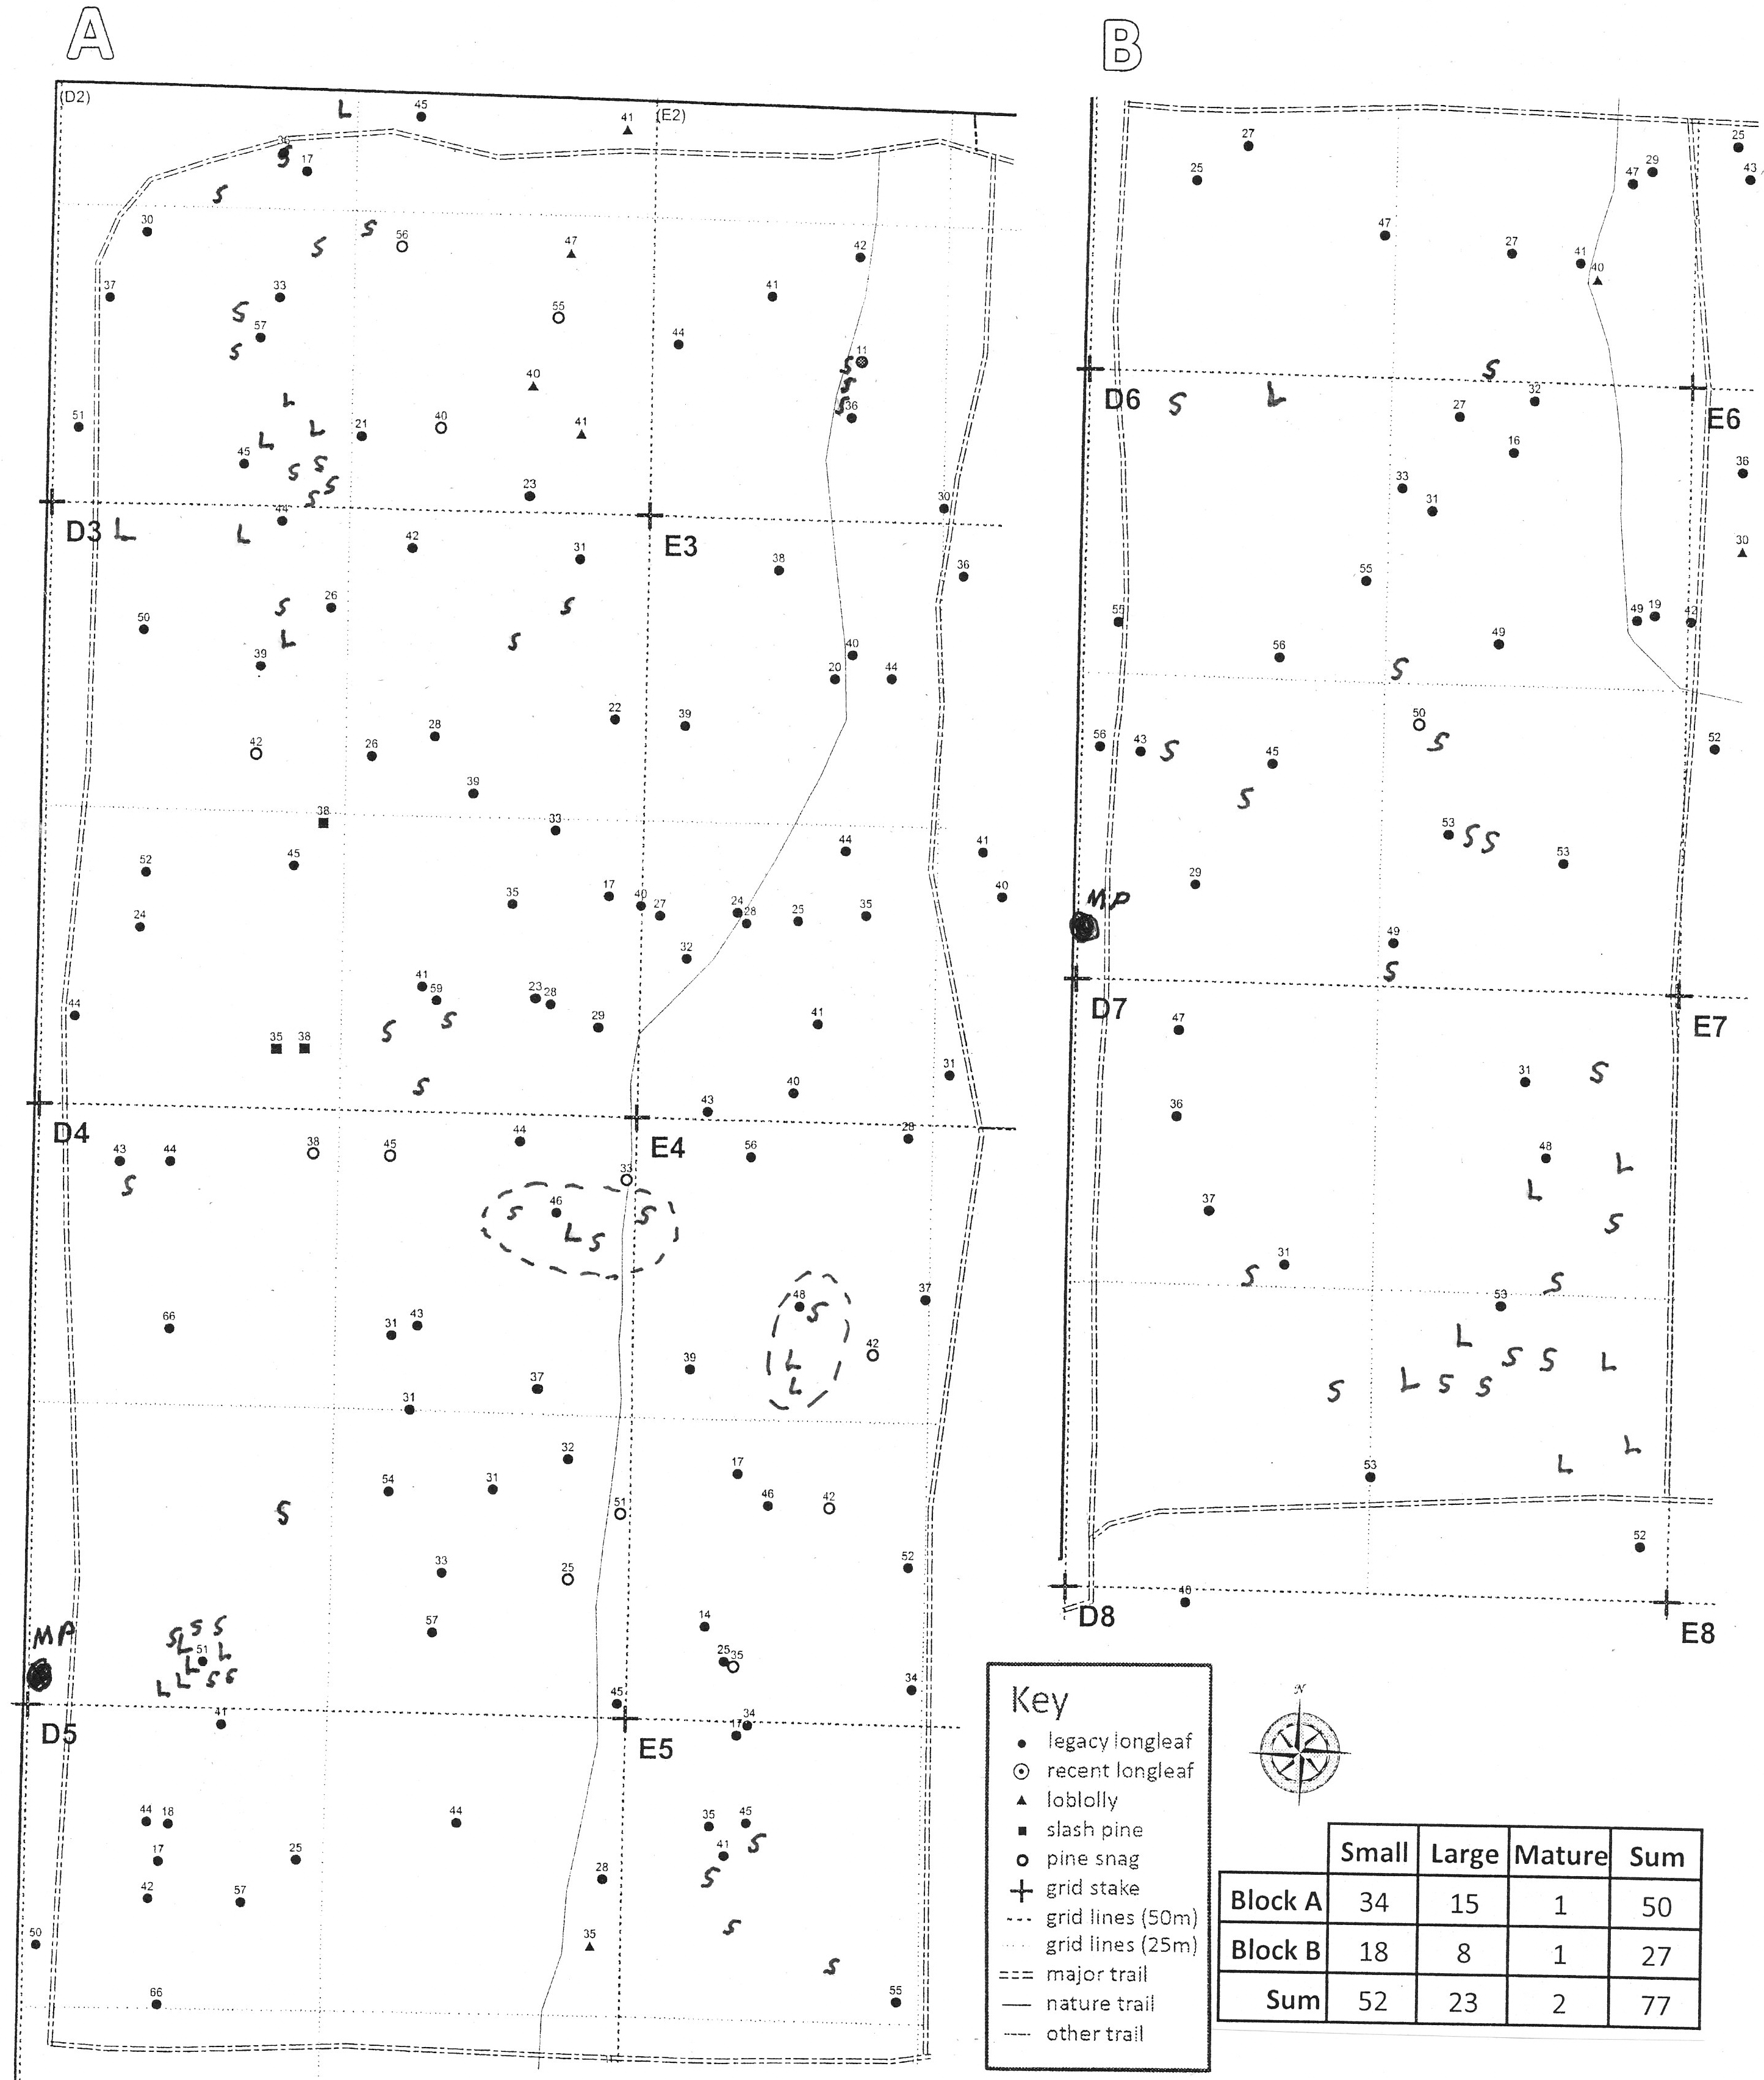
Fig. 1. Occurrence of cabbage palms in Blocks A and B of NATL’s upland pine, April 2014. With printed symbols (see Key) and small numbers, the base map for this figure shows the species, position, and DBH of each mature pine in the two blocks. The size category and position of each juvenile cabbage palm are shown by a hand-written “S” (small) or “L” (large). Just north of grid stakes D5 and D7, the two mature cabbage palms are indicated by “MP” above a large black dot. In Block A, the eight juvenile palms within the two dashed-line ellipses could be used to illustrate NATL’s problem with palms invading its restored upland pine. In the table at lower right, the 77 cabbage palms are tallied by block and developmental category.

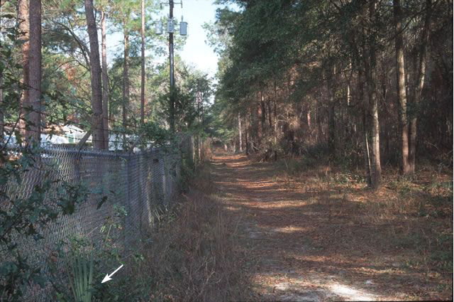
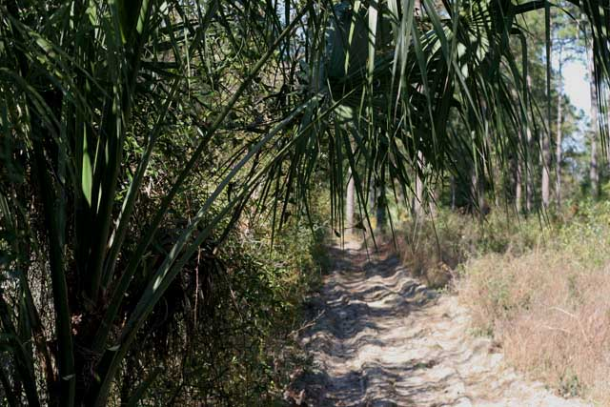
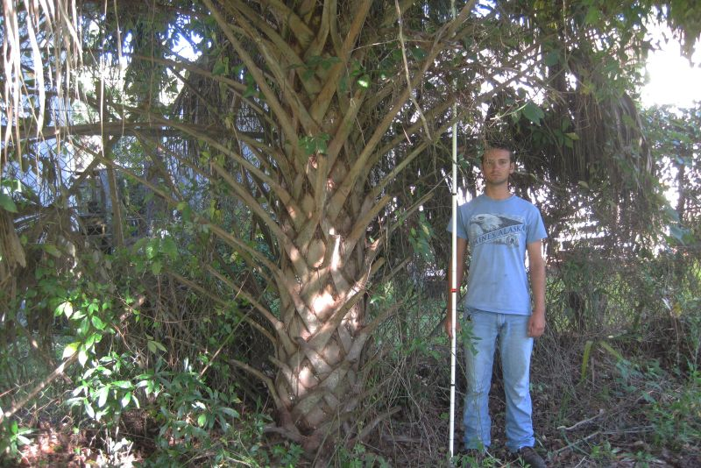
Fig. 2. Cabbage palm just north of NATL gridpoint D5, in 1997, 2007, and 2014.
For details see http://natl.ifas.ufl.edu/photogallery/D5n.htm.
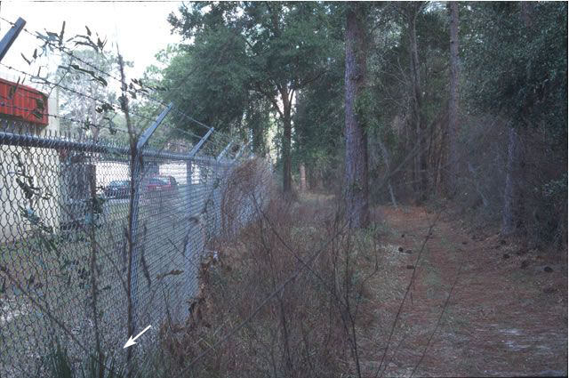
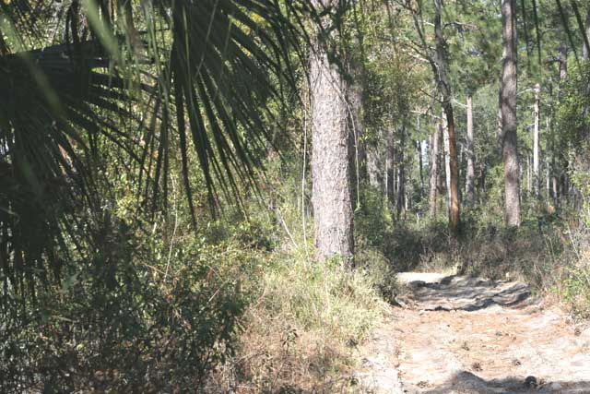
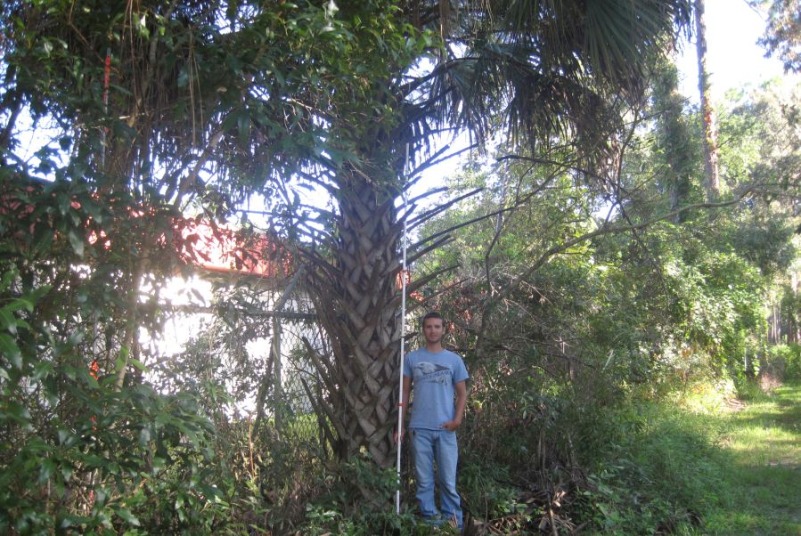
Fig. 3. Cabbage palm just north of NATL gridpoint D7, in 1997, 2007, and 2014.
For details see http://natl.ifas.ufl.edu/photogallery/D7n.htm.
Addenda
While drafting this document I continued to seek information from others about comparable increases in cabbage palms in other stands of upland pine. Here are relevant results from those enquiries:
On 20 Aug 2014, David Fox (PhD Candidate and Graduate Assistant in Forest Systems, UF School of Forest Resources & Conservation, who has cabbage palms as his dissertation topic) wrote, “One hypothesis of why NATL is 'suddenly' becoming infested with Sabals might be that urban development and landscaping has moved cabbage palms into a region of Florida where they historically were scarce.”
The following day he visited UP Blocks A&B in NATL and found that their invasion seemed to fit his hypothesis. He noted that the removal of the two mature palms next to the DPI fence would be unlikely to have much effect on the numbers of cabbage palm seeds deposited by birds who had recently fed on the fruit, because cabbage palms were abundantly planted as part of the ssurrounding urban landscape. In support of this notion he pointed out a cluster of 10 immature palms surrounding one 51cm DBH longleaf pine. This pine had an expanded flattened crown that he noted would offer an extensive set of perches that might attract birds that were digesting palm fruits they had recently eaten. (In Fig. 1, this clump of young palms is immediately east of grid stake D5.)
Some of these birds may have fed on the fruits of the two naturally planted mature palms growing within the area shown in Fig. 1. However, this longleaf pine is also a short flight from the 99 cabbage palms used to landscape UF’s Cultural Plaza and its parking garage, and no disturbance-free, attractive perch may be closer. Palms established in the urban landscape, unlike the two along the DPI fence, generally have no competing vegetation
In a 30 Sep 2014 email, Anne Barkdoll (Florida Division of Recreation and Parks, Department of Environmental Protection) wrote that “Anecdotally I have observed that palms (Sabal palmetto) seem to be increasing and others have mentioned it too but I don't have a specific research paper to direct you to. I did look very quickly into the literature and found this brief discussion of palm density increasing with fire frequency in the everglades and in hammocks in north Florida, http://www.fs.fed.us/database/feis/plants/tree/sabpal/all.html . It does contain a few references to fire effects on palms. Your observations seem to fit with what is mentioned in this reference.”
She also noted, “We have had parks that removed palms along fire lines and property boundaries to improve the safety of prescribed fire. I think at least one park has reduced the density of palms in the interior of a management zone but the habitat was flatwoods.”
In a phone call on 6 Oct 2014, Anne Barkdoll stated that she had learned that Crystal River Preserve State Park was actively managing invading cabbage palm in their longleaf pine flatwoods habitat. She later gave me contact information for the Park Biologist, Keith Morin. In phone calls of 17 and 24 Oct 2014 and in follow-up emails, Keith explained that the tract where he was managing cabbage palms had been planted with slash pines in 1973. From then until the State acquired the property in 1998, the property was not burned and no trees were harvested. During those 25 years the pines grew tall and cabbage palms, which were scarce or absent in 1973, became abundant. At the start of the palm management program in 2007, the DBH basal areas of the trees in the experimental area was in excess of 110sqft of DBH basal area/acre with the slash pines accounting for 52, with the remaining >58 being cabbage palms. Measurements in 2013 showed that the basal area of the palms had been reduced to 26 and that third-row thinning in 2007 had reduced the basal area of the pines to 31. The long term goal of the management plan is to reduce the basal area of the palms to 5sqft/acre, to plant only longleaf pines, and to manage the longleafs to a density of 30-45/acre.

